**Use Case Diagrams**

Use Case Diagrams illustrate the relationship between the user and the system during specific scenarios of the user interacting with the system. During development, this can be very beneficial to the development team as it demonstrates the ideal outcomes for given situations which makes testing a lot easier as it can show instantly whether the implementation of a feature was successful or not.

**Scenario 1 – Logging Into The System**

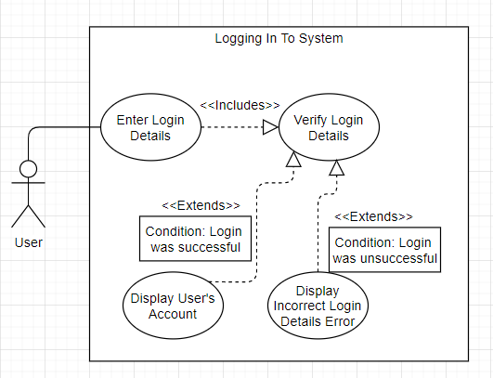

This use case diagram shows the process of trying to login to our system.

**Scenario 2 – Creating A User Account**

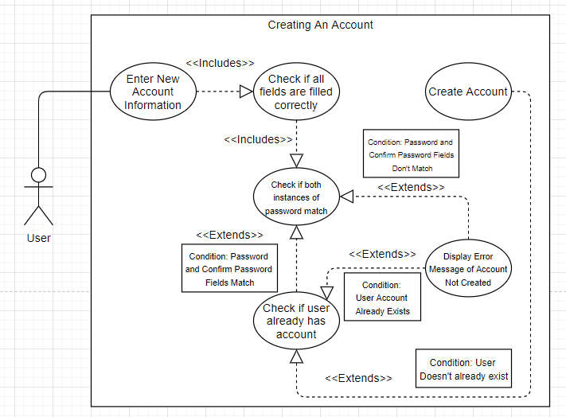

This use case diagram shows the flow of events of creating a user account on our system.

**Scenario 3 – Requesting Data From The Server**

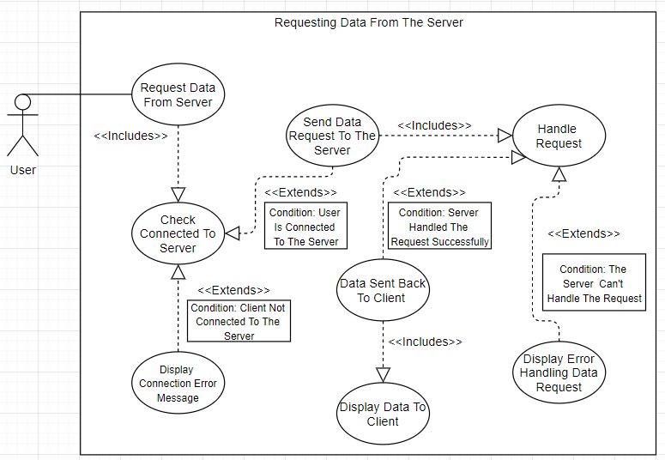

This use case diagram shows the process of the actor, the user requesting data from the server.